1. 1. 
   2. Done in r Code
   3. 
   4. 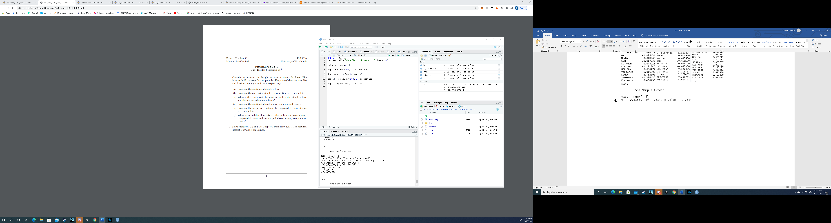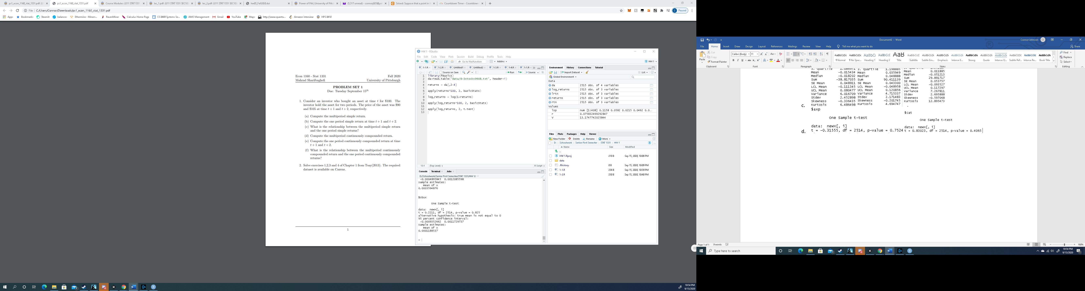

All three p-values are greater than 0.05 so fail to reject the null hypothesis for all means

1. 1. 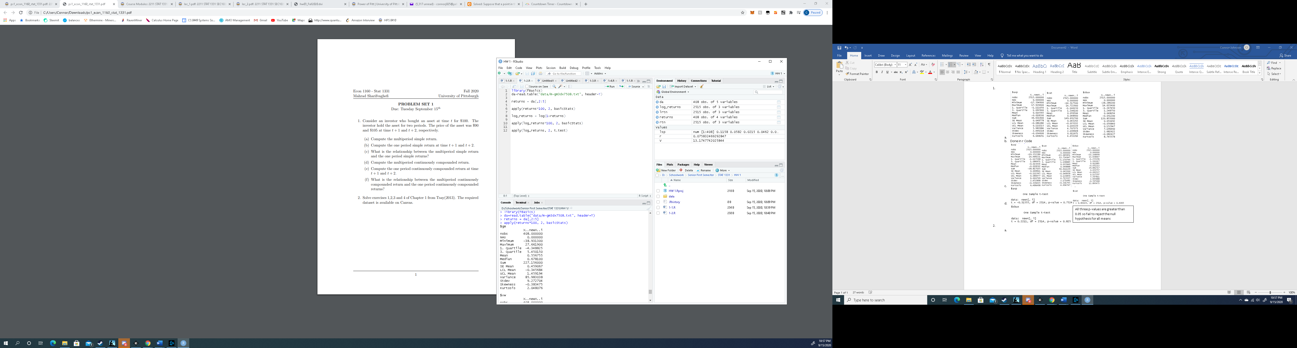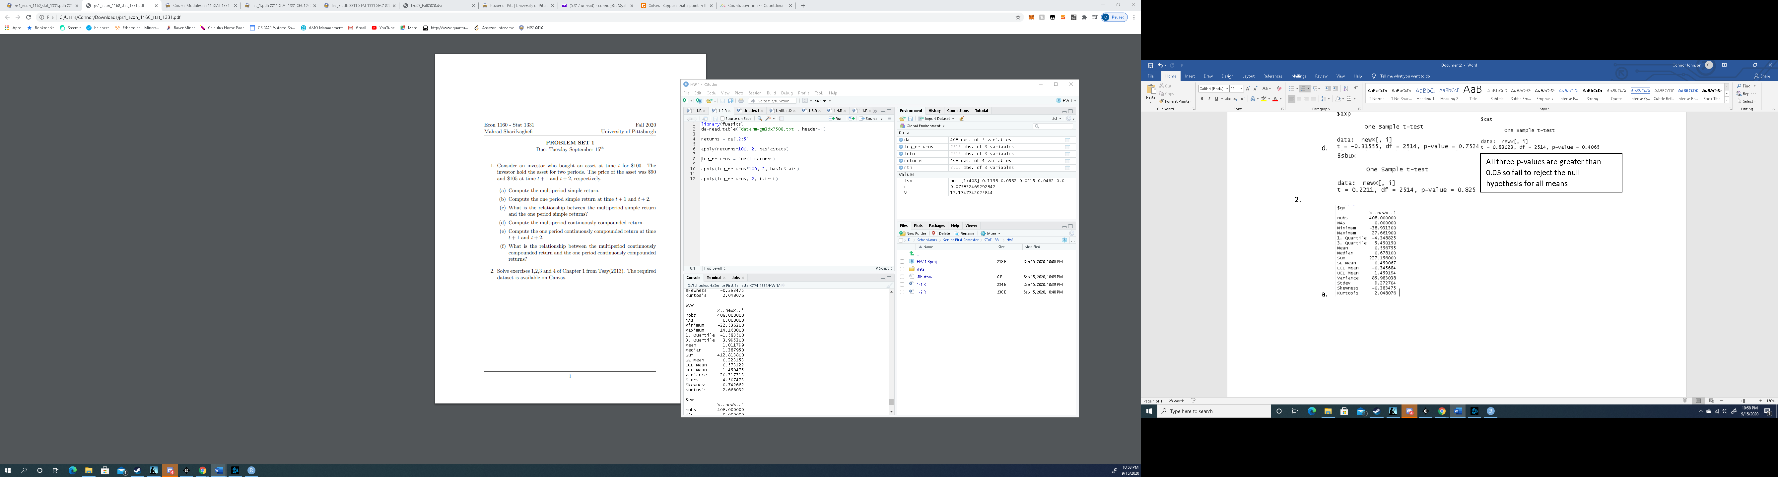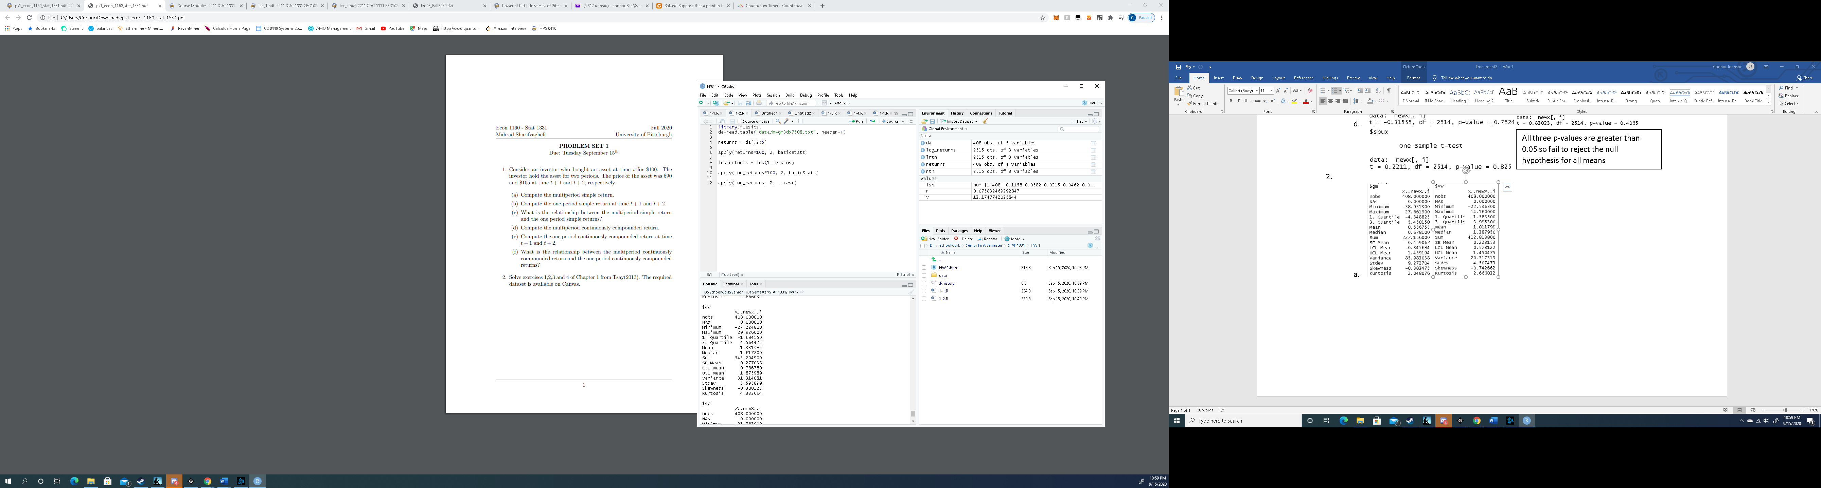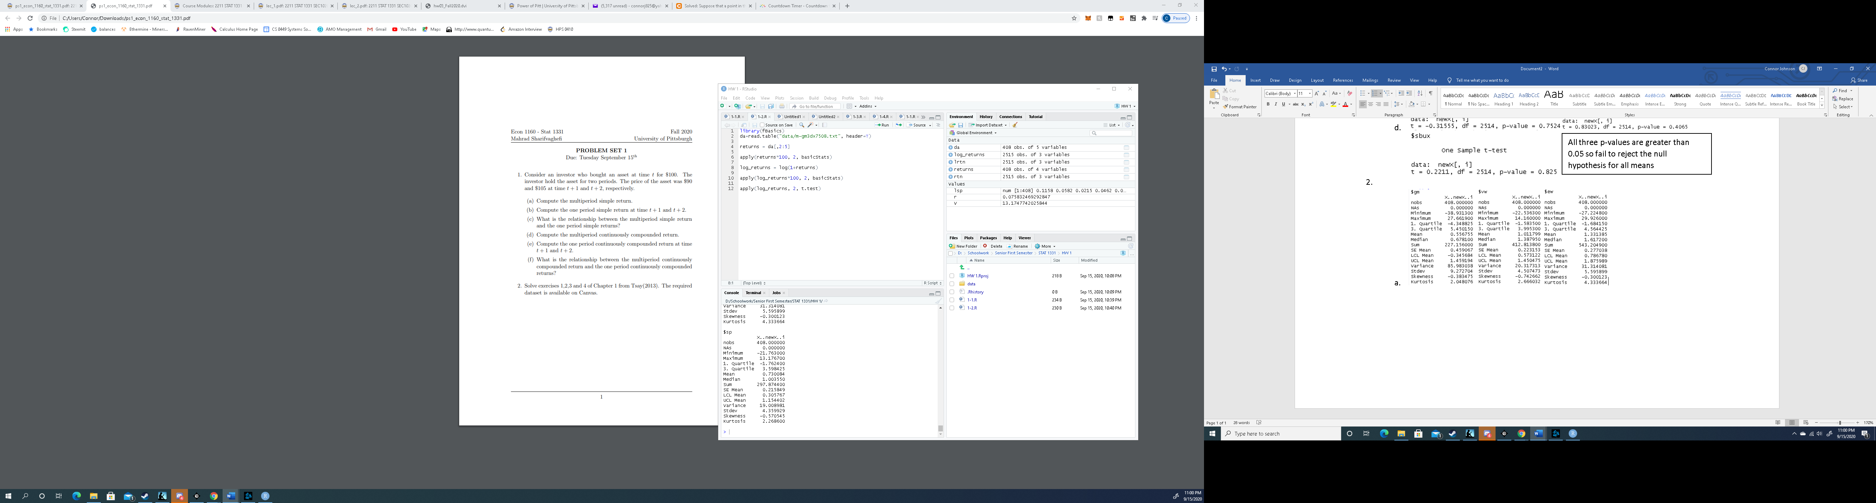
   2. Done in R code
   3. 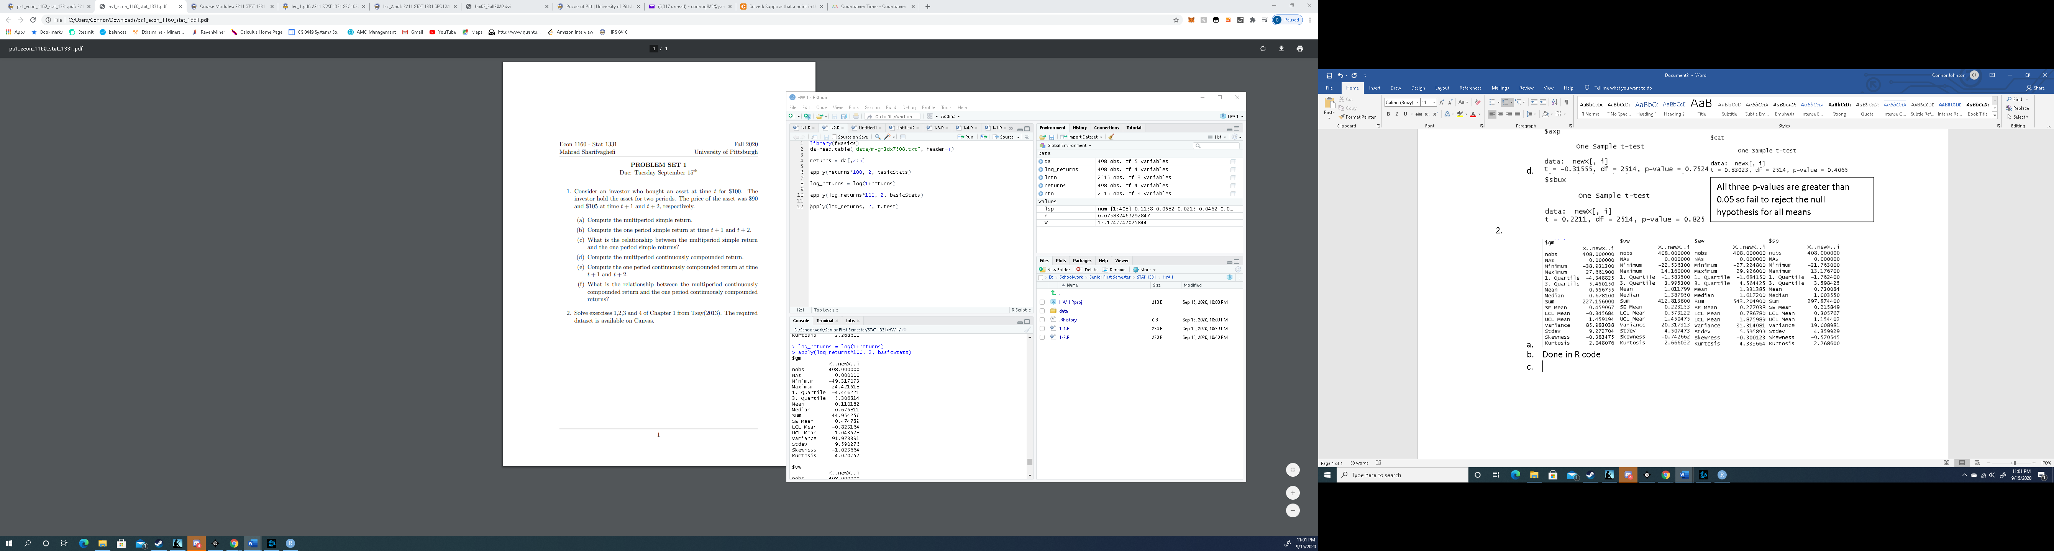
   4. 

S&P:

Null Hypothesis: Mean = 0

Alternate Hypothesis: Mean ≠ 0

P-val is less than 0.05 so reject the null hypothesis. Conclude the mean is significantly different from 0.

EW:

Null Hypothesis: Mean = 0

Alternate Hypothesis: Mean ≠ 0

P-val is less than 0.05 so reject the null hypothesis. Conclude the mean is significantly different from 0.

VW:

Null Hypothesis: Mean = 0

Alternate Hypothesis: Mean ≠ 0

P-val is less than 0.05 so reject the null hypothesis. Conclude the mean is significantly different from 0.

GM:

Null Hypothesis: Mean = 0

Alternate Hypothesis: Mean ≠ 0

P-val is greater than 0.05 so fail to reject the null hypothesis. There isn’t enough evidence to conclude the mean is significantly different than 0.

1. 1. Annual Log Return = 0.07583247
   2. Investment Value = $13.17

a. Null Hypothesis: Skewness = 0, Alternate Hypothesis: Skewness ≠ 0

Z-Score = 1.96, Test Statistic = -6.88, 6.88 > 1.96

Reject the null hypothesis and conclude the skewness is significantly different from zero.

b. Null Hypothesis: Kurtosis = 0, Alternate Hypothesis: Kurtosis ≠ 0

Z-Score = 1.96, Test Statistic = 66.40, 66.40 > 1.96

Reject the null hypothesis and conclude the kurtosis is significantly different from zero.